1669. Merge In Between Linked Lists
Medium

You are given two linked lists: list1 and list2 of sizes n and m respectively.
Remove list1's nodes from the ath node to the bth node, and put list2 in their place.
The blue edges and nodes in the following figure indicate the result:
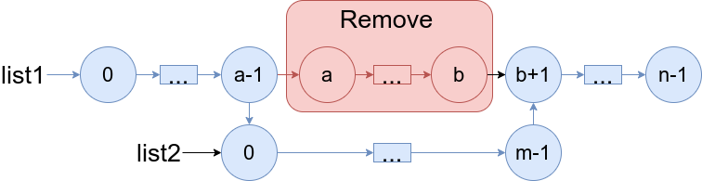
Build the result list and return its head.

Example 1:
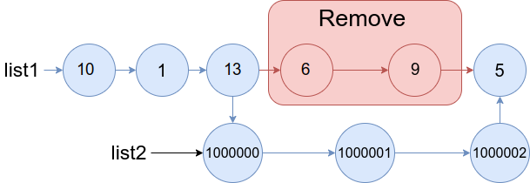
Input: list1 = [10,1,13,6,9,5], a = 3, b = 4, list2 = [1000000,1000001,1000002]
Output: [10,1,13,1000000,1000001,1000002,5]
Explanation: We remove the nodes 3 and 4 and put the entire list2 in their place. The blue edges and nodes in the above figure indicate the result.
Example 2:
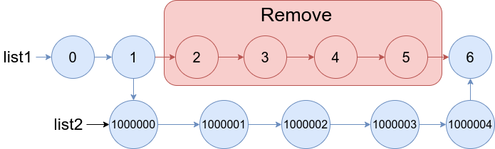
Input: list1 = [0,1,2,3,4,5,6], a = 2, b = 5, list2 = [1000000,1000001,1000002,1000003,1000004]
Output: [0,1,1000000,1000001,1000002,1000003,1000004,6]
Explanation: The blue edges and nodes in the above figure indicate the result.

Constraints:
- 3 <= list1.length <= 104
- 1 <= a <= b < list1.length - 1
- 1 <= list2.length <= 104

